1. ．Why the text decoration wont work in my editor?

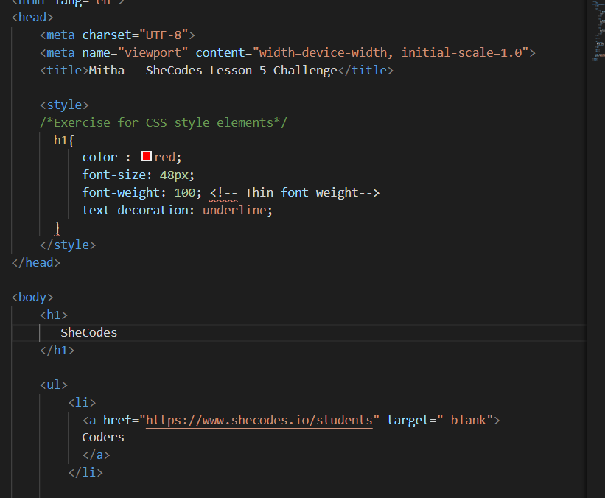

I found that the following was working instead

